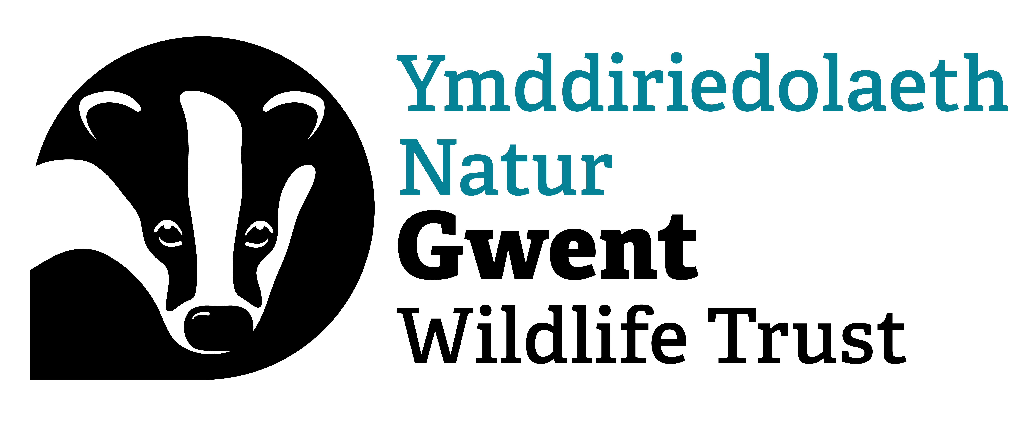
Youth Action Group Leader (Volunteer): Role Description

Location: Magor / Newport
Gwent Wildlife Trust runs a youth programme supporting young people aged 9–24 who want to take positive action for wildlife and tackle the impacts of climate change.
Our focus is on empowering young people to feel confident in making positive changes - both big and small. This includes using nature-based solutions wherever possible, such as creating wildflower meadows, planting trees, and establishing rainwater gardens or green roofs. We prioritise listening to young people, helping them find their voice, and supporting them to stand up for their beliefs.

In this volunteer role, you will be responsible for leading the Wildlife Warriors youth action group, based at Magor Marsh, fortnightly. You will work alongside staff, other volunteers and the youth group members to feed into session planning, ensuring that young people’s ideas and interests are reflected in the activities you will be responsible for delivering. Session plans and overall programme structure will be developed by GWT staff. Wildlife Warrior sessions are predominately based at Magor Marsh, but on occasion will take place at other GWT Nature Reserves and in community spaces.

Support and Supervision
- Session plans and activity resources will be provided by the GWT Youth Engagement team
- You will feed into session planning by sharing young people’s ideas and interests
- You will receive safeguarding training and ongoing support from GWT Staff
- A member of staff will be your main point of contact for support, questions or safeguarding concerns
- GWT staff are responsible for programme planning, risk assessments, reporting and project coordination

Desirable Skills & Experience
- Ability to lead a youth group meeting and manage a group of 15–20 young people, ensuring the sessions are safe and engaging
- Strong listening skills and the ability to communicate effectively with young people
- Ability to coordinate and support other volunteers who will be assisting you during the session
- Ability to work as part of a team
- Hands on DIY skills are an advantage, or a willingness to get involved and learn
- Comfortable working indoors or outdoors in a variety of weather conditions
- Previous experience in teaching or youth-related work is beneficial

Notes / Special Requirements
- The recruitment for this role will involve an informal interview
- This volunteer role is subject to an Enhanced and Barred DBS check
- The role offer is subject to the receipt of two satisfactory references, who should be able to comment on your suitability for the role
- You will be expected to complete safeguarding training and adhere to GWT Safeguarding Policies and Procedures.
- You will need access to your own transport, lifts, or public transport to travel across Gwent, however, volunteer travel expenses will be paid
- You will need to show evidence of holding, or complete before commencing the role, Outdoor First Aid training. GWT will cover the cost of this as required.
- To comply with our Safeguarding and GDPR policies, you will be issued with a GWT mobile and email address for the duration of your volunteer role
- You will be expected to participate in additional training as it becomes available

Benefits to You
- Be part of a movement inspiring young people to make a positive difference
- Gain experience, receive training, and develop new skills
- Spend time outdoors taking part in rewarding, hands-on activities
- Build a deeper understanding of climate change issues and solutions

Time Commitment
- Availability to facilitate Wildlife Warrior sessions fortnightly, on Tuesdays, 6-8pm, at Magor Marsh. This also includes arriving beforehand to set up the space and clearing up after the session.
- Availability to correspond with GWT staff between sessions for session debrief, evaluation and planning.
- Availability during school holidays is an advantage - school holiday workshops or events may last a few hours or a full day

For an informal chat about this role, please contact Robert Magee rmagee@gwentwildlife.org

To apply for this role, please use the application form attached to the advert.

This agreement is not binding in any way, nor is it a contract of employment.

