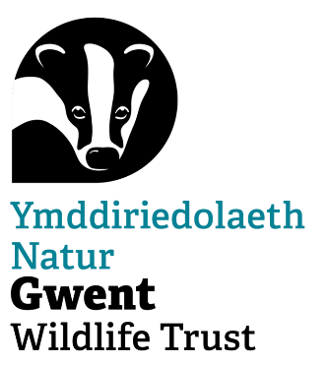
Nature Recovery Land Management Volunteer Role Description

Location: GWT Nature Reserves as advertised on Team Kinetic

Land management activities take place out on our reserves and involve practical land management tasks which vary by reserve and season. The primary aim of managing these sites is to conserve their features now and for future generations using well established techniques to manage the land for conservation.

Responsibilities
- Helping improve our nature reserves for both wildlife and people
- Boundary management e.g. repairing/replacing fences, laying hedges, mending dry stone walls.
- Access maintenance and improvement to increase accessibility, e.g. maintaining paths/walkways, cutting back, mending gates and stiles.
- Summer/autumn habitat management tasks: Control of invasive species, raking off meadow cuttings, meadow restoration e.g. green-haying and bracken bashing,
- Winter habitat management tasks: Scrub clearance, coppicing, tree planting and hedge laying,

All tasks are guided and supervised by appropriately trained and first-aid qualified Gwent Wildlife Trust staff.

Time Commitment
Land Management tasks currently take place on Tuesdays, Wednesdays and Thursdays at various reserves across Gwent. Tasks usually start at 10am and finish about 3pm. Sometimes the tasks carry on until later, and if you wish to stay on the help is always appreciated. You can sign up to attend our volunteer opportunities to suit your own routines and schedule. Activities and tasks may vary according to the season and requirements of the site

Attendance at land management tasks is completely voluntary and there is no set time commitment. You may want to help each week, or only once a year, or perhaps only on certain tasks or at certain sites. Attendees may finish early or skip certain tasks during the day, according to their own schedules and physical capabilities.

Training and Support

- No previous experience necessary
- Land Management tasks can often be physically demanding and may be carried out on remote reserves
- The work is varied throughout the year and dependent on the season, but there is always something for all abilities. We will provide all tools and protective equipment but please wear sensible clothing for the time of year and sturdy work boots (steel toe caps if you have them) and bring a packed lunch.
- On-site toilet facilities are available at; Pentwyn Farm, Wyeswood Common, and Magor Marsh

Volunteers are given an induction and training will be provided for tasks. Opportunities for further training will be given as required or when funding is available.

The member of staff listed on the Volunteer Opportunity on Team Kinetic is responsible for leading and supporting you as a volunteer.

This agreement is not binding in any way, nor is it a contract of employment.

