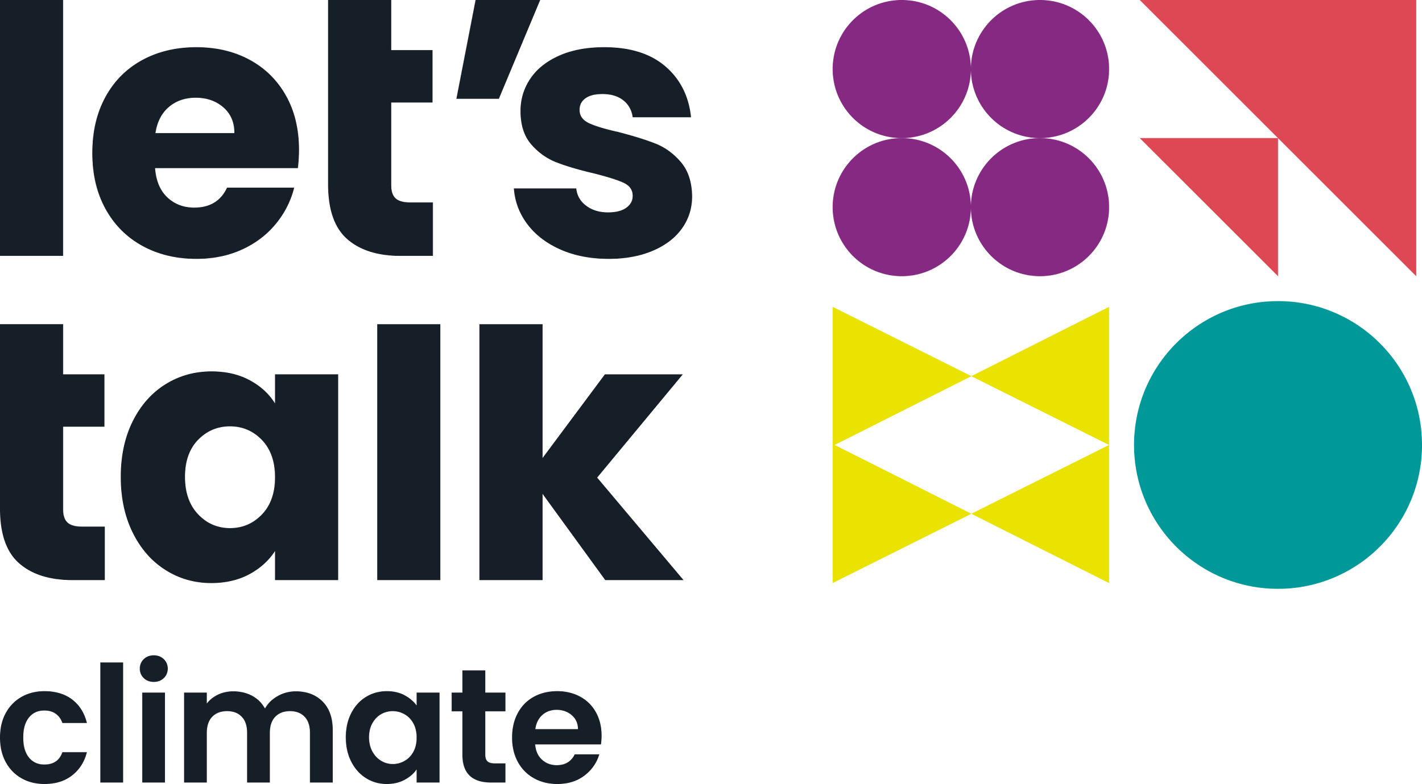

Welcome to the Workshop!

If you’re someone who cares about the impacts of climate change but you’re unsure how best to start conversations about it, this training is for you.

Conversations are powerful! And skilful climate conversations have the potential to build support for climate action locally and nationally.

We’re on a mission to get people talking in their community - with their neighbours, at the school gate, at places of worship, after a fitness class or on the dog walk. This is your chance to join a movement of people learning how to talk with others about climate change.

Perhaps you’re worried about coming across as preachy or judgemental. You might not feel like you’re ‘expert’ enough when it comes to climate science. Or maybe you just can’t find the right words. Whatever’s getting in the way - we’re here to help! Join us for this 2-hour, online session where you will:

- Connect with others who care about climate change.
- Identify barriers that are holding you back and ways to overcome them.
- Learn practical tips on how to get conversations started.
- Find out what helps conversation to go well once you’ve got going.
- Practice your skills in a friendly, low-pressure environment.
- Access our Workbook with extra resources to help you on your way.

This training has been tried and tested by people just like you who are now confidently getting conversations started in their communities

We hope you’ll join them!

