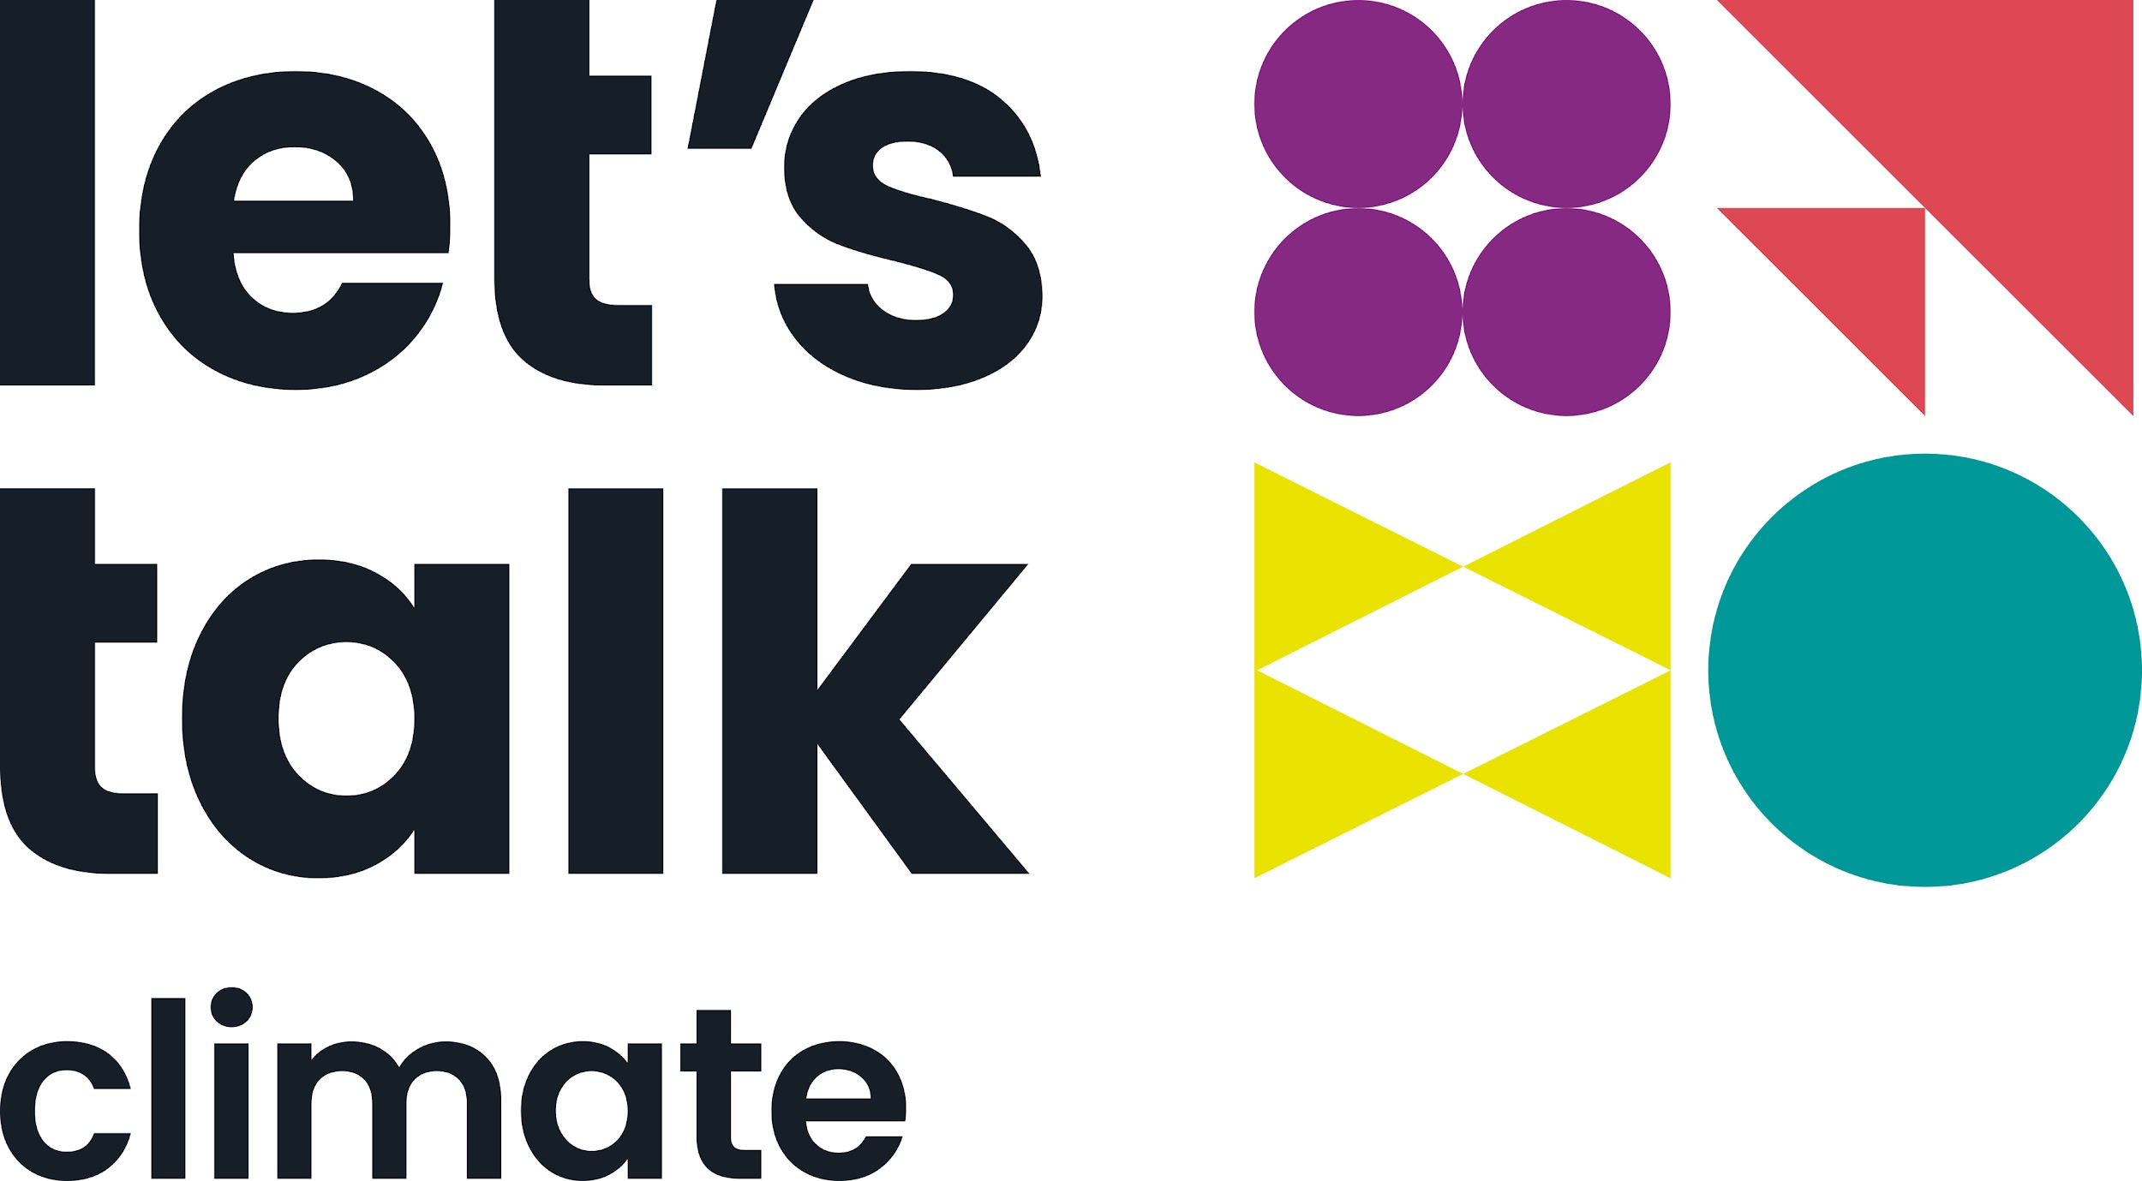

Get set for the Challenge!

The Challenge is for people who really want to commit to becoming a climate conversation champion! It picks up where the Workshop leaves off…

You’ll be joining a small group of like-minded people online for an hour each week for 6 weeks. Together you’ll learn, build on your skills, support each other and share your conversation experiences.

Learning together

Research tells us that we all learn better in a social environment and this is a great opportunity to do just that.

We’ve designed the Challenge to directly address the things we know stop us from having conversations about climate - fears like:

- Not knowing how to start the conversation in the first place
- Coming across as preachy, judgemental or inauthentic
- Not having the facts at hand to counter people’s arguments
- Letting your feelings about the climate crisis run away with you
- Talking to people with different backgrounds and/or values to yourself

Learning skills for life

And don’t forget, in learning about how to have better conversations about climate, you’ll also be building skills for life like:

- Recognising your own biases, triggers and pressure points
- Communicating in a way that connects with and engages people
- Unlearning assumptions and/or ways of doing that aren’t helpful to you
- Becoming more curious about the people and situations you encounter
- Building resilience so you don’t suffer from burnout

Week-by-week overview

Week | Theme | Topics and skills
1 | Getting set | - Getting to know each other  - Understanding barriers and how to address them  - Setting intentions for the weeks ahead
2 | Relationship foundations | - Self-awareness and recognising our biases  - Developing rapport with people  - The art of active listening
3 | Telling your tale | - Information vs emotion  - Telling the story of how you came to climate action  - How to share a story that resonates
4 | Doing no harm | - Recognising and handling our triggers  - Knowing when not to have a conversation  - Avoiding burnout and recharging with allies
5 | Bridging difference | - The different types of empathy  - Cultivating curiosity, demonstrating respect  - How to ask open-ended questions
6 | Inspiring action | - Reflecting on our achievements  - Sharing our personal/group takeaways  - Setting next steps - individually and collectively

What past participants said they valued most about the Challenge

“It's given me the confidence to go out there and try - which I was always very hesitant about in the past.”

“I struggle a lot in social situations and often say the wrong thing when I am emotional/passionate. This has taught me how to think through and engage with the person I am talking to.”

“Feeling supported and pushed to step out of my comfort zone and seek to connect with people I may not know well. Whereas previously I might have kept to myself or stuck to small talk in certain settings, I feel emboldened now to make more meaningful conversation.”

“Coming together in a small group where everyone's on the same page, and having a space to share our feelings and experiences.”

“I liked the practical advice, tips and perspective offered by the Workbook. I liked the chance to be accountable and feedback every Wednesday.”

“Having a deeper appreciation of listening to really understand the other person, not just listening to add my point of view, really getting to the crux of what they believe and what they care about.”

“Having a group to work through these ideas with has helped keep me accountable and encouraged me to have conversations even when I don't think it's the 'right' time or the 'right' person.”

“Speaking to my little group once a week, knowing we're not alone!”

“Learning to be curious and to ask questions rather than explain topics. Not only does this help people explore their own biases and opinions but it has helped me challenge my prejudices and stereotypes. “

“Finding my tribe, sharing a passion”

