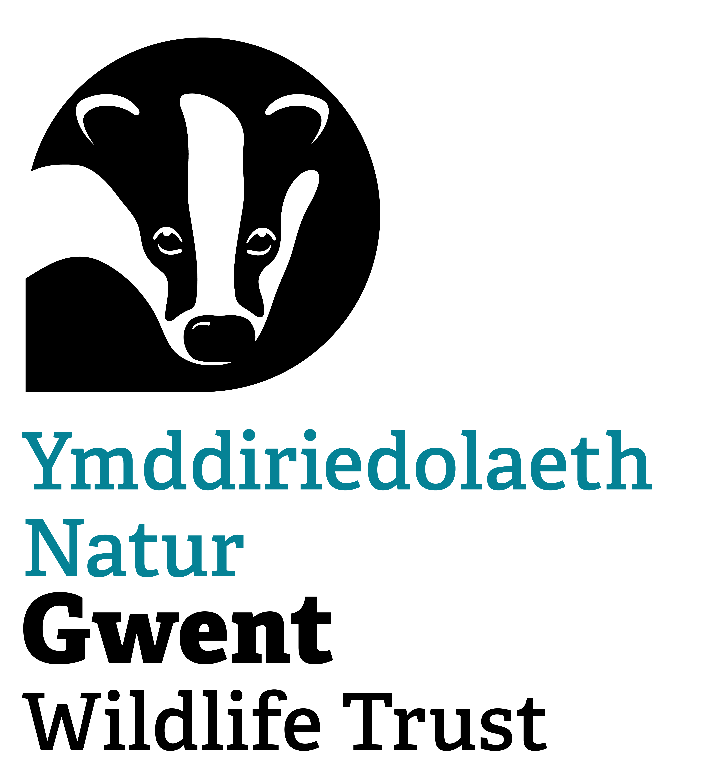
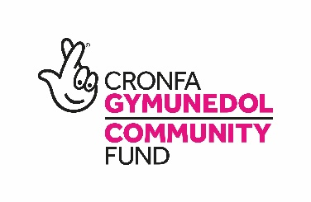

Gwent Wildlife Trust

Youth Engagement Officer

Title: Youth Engagement Officer
Contract: Fixed Term until 31st March 2026 (with possibility of extension)
Hours: Part Time. 22.5 hrs per week (0.6 of FTE) to include fortnightly Tuesday evenings 5.30-8.30pm. All other hours are flexible. Some weekend work could be required.
Reports to: Senior Youth Engagement Officer
Responsible for: Project Volunteers
Location: Working with young people across Gwent but with a focus around Magor and Newport. Working flexibly from home and any GWT Office
Salary: £26,473 FTE (£15,883 actual)

Overall purpose
To support and deliver Gwent Wildlife Trust’s element within the pan-Wales youth-led Stand for Nature Wales (SFNW) Project, funded by the National Lottery Community Fund’s Climate Action Fund. To support and implement Gwent Wildlife Trust’s wider Youth Engagement programme, facilitating meaningful engagement with schools, colleges, universities and alternative education.
Main responsibilities
- Hold responsibility of the SFNW Newport project at GWT and deliver activities which will successfully achieve the outputs by 31st March 2026. This will include but is not restricted to:
  - Work closely with the rest of the youth engagement team at GWT.
  - Consult with and listen to local groups and young people to determine community requirements and reflect this in the project delivery.
  - Identify and develop partnerships with other groups, networks and organisations, to fulfil the aims and vision of the SFNW project.
  - Develop and nurture youth groups or youth forums, of local young people, wishing to take action against climate change, and support and empower them to take the action.
  - Design and implement a range of events or activities aimed at inspiring and teaching young people and their families about positive actions for climate change. These could be in formal educational settings, informal settings and through community activities.
  - Support young people to take positive action for climate change through nature-based solutions by working with GWT colleagues in the Nature-Based Solutions and Nature Recovery teams, partner organisations and external expert facilitators.
  - Enable and support young people to engage with the wider community, ensuring the buy-in of local stakeholders and helping to boost the profile of local climate action activities.
  - Support schools to facilitate more nature-based activities themselves, through teacher training and curriculum development support.
  - Compile and submit project reports to funders and ensure that the project is continually monitored and detailed records are maintained.
- Work with the Head of Nature-Based Solutions, Senior Youth Engagement Officer and the Fundraising Manager to identify, devise and develop future funding opportunities for this area of work.
- Facilitate school visits onsite as well as school outreach opportunities.
- Read and abide by all of GWT’s Policies, Processes and Practices with particular reference to the Staff and Organisational Handbooks, HR Policies and Health and Safety Management System.
- Communicate and promote our youth engagement work as well as the wider work of GWT, through a variety of media, working with the Marketing Team to do so.
- Develop and maintain good relationships with partners, neighbours and volunteers.
- Attend meetings of the Trust including but not limited to All Staff and One to Ones.
- Promote membership of GWT and represent your work and GWT’s projects and campaigns in the media as required.
- Carry out any other varied duties that may be required, appropriate to the nature of the post.

The Post
The Youth Engagement Officer will play a key role in the successful delivery of the SFNW project within Gwent, funded by the National Lottery Community Fund’s Climate Action Fund. They will have responsibility for the day-to-day management of their activities, reporting to and being supported by the Senior Youth Engagement Officer. You will have responsibility for facilitating our well-established youth led action group, Wildlife Warriors, who meet fortnightly on a Tuesday evening in Magor, as well as working with schools, communities and alternative education providers to implement GWT’s wider youth engagement programme and enable more people to undertake meaningful action for nature.

The SFNW project aims to achieve a Wales richer in wildlife; where habitats and landscapes capture more greenhouse gases; and where young people (aged 9-24) influence their peers and communities to take positive action to tackle climate change. The vision of the project is a climate and conservation conscious Wales, where empowered young people drive change in behaviours. The role will be expected to engage, train, facilitate and empower young people in Gwent to learn about, find a passion for and take action to tackle climate change through natural solutions. Through continuous monitoring, reflection and evaluation, the role will ensure that the Stand for Nature Wales Project is meeting its objectives of upskilling and empowering young people to take action for the climate and for nature in their local communities, sequestering carbon, creating spaces for nature and giving young people a voice in local decision making.

The Youth Engagement Officer sits within the Nature-Based Solutions Team, which oversees our work to help nature to help us. This role will work alongside a Senior Youth Engagement Officer, two Wild Health Officers, a Community Organiser and a River Restoration Officer. They will join a well-established, high performing team with a long track record of and experience in engagement and education delivery to all ages and abilities.

The position is subject to an enhanced and barred Disclosure and Barring Service check.

Candidates should be able to demonstrate commitment to equal opportunities, be able to work out-of-office hours when required. The post holder will be required to attend other meetings elsewhere in Gwent and occasionally elsewhere in the UK.
PERSON SPECIFICATION
The qualities needed for this post are listed below.
(E – Essential; D – Desirable)

Experience
- Demonstrable experience of working with young people in an outdoor environment. (E)
- Building and maintaining strong relationships with partner organisations, local community groups, volunteers and young people (E)
- Facilitating youth-led activities with young people from a range of backgrounds (E)
- Supporting, developing and empowering young people to find their voice (E)
- Record-keeping and reporting internally and to funders (E)
- Development and implementation of Health and Safety Codes of Practice and Risk Assessments (E)
- Organising and delivering public events (E)
- Carrying out nature-based solutions or habitat management works, particularly with local communities and within urban environments (D)

Skills
- Good communication skills - written and oral - with people from a range of backgrounds (E)
- Excellent interpersonal skills - critical-listening, mediation, persuasion (E)
- Excellent attention to detail (E)
- Full driving licence (E)
- Ability to work in a busy environment to deadlines, managing multiple priorities (E)
- Ability to work independently, using own initiative, as well working as part of a team (E)
- IT literate (E) - Microsoft Office including Excel (E)
- Welsh Language (D)

Knowledge and Qualifications
- Knowledge of the youth and environmental sectors (E)
- Knowledge of UK wildlife conservation and climate change issues (E)
- Understanding nature-based solutions to climate change and how they can be applied in Wales (E)
- Evidence of successful study in a relevant subject (e.g. youth development, primary or secondary education, environmental science, ecology) (D)

Personal Qualities
- Inquisitive and solutions focussed, always seeking to improve their teams work (E)
- Creative and pragmatic in problem solving (E)
- Eager to learn and implement new skills for the role (E)
- Able to convey enthusiasm and inspire people to become involved (E)

