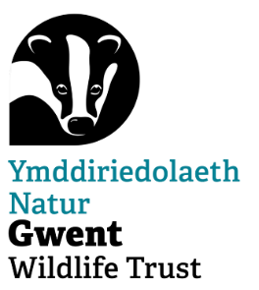

**Nature Recovery**

**Water Vole Project Volunteer Role**

**Purpose and Location**

In 2012, we successfully re-introduced water voles back onto Magor Marsh nature reserve, on the Gwent Levels, where they are still thriving today. Following the success of this reintroduction, we are now looking to extend the project to encompass the western side of the Gwent Levels (Wentlooge).

To help us achieve this we need volunteers to help us carry out Water Vole and American Mink surveys on the Gwent Levels.

**Responsibilities**

* Monitor the site on a weekly basis
* Record and report any evidence of Water Vole or American Mink activity
* Support the project officer with the siting of mink traps

All training is carried out by appropriately trained and first-aid qualified Gwent Wildlife Trust staff. Training will be provided and no previous experience is needed.

**Time Commitment**

Water Vole and American Mink surveying should be carried out weekly. Days and times are chosen by the volunteer, according to their own schedules. The time spent on site may vary depending on the site conditions and physical capabilities (walk to and from site, weather conditions etc.). Involvement with the project is completely voluntary and there is no binding time commitment, however for the project to be successful, regular surveying will be needed.

**Training and Support**

* No previous experience necessary
* Full training and any equipment needed will be provided
* Be part of a surveying group that can provide support and guidance

Kevin Donovan is responsible for leading and supporting you as a volunteer [kdonovan@gwentwildlfe.org](mailto:kdonovan@gwentwildlfe.org)

This agreement is not binding in any way, nor is it a contract of employment. Please inform the volunteer coordinator if you are unable to continue surveying so that we can ensure the site continues to be monitored and surveyed.