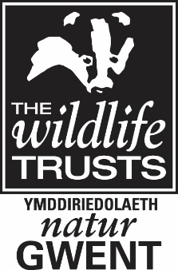

Gwent Wildlife Trust

TRUSTEE APPLICATION FORM

Name:
Address:
Email address:
Telephone number: |  | Date of Birth:

1. Please provide a short biography of yourself including a career summary.

2. All Trustees have to be a member of the Gwent Wildlife Trust. If you are one already, what motivated you to become a member of Gwent Wildlife Trust?
3. Why do you want to be a Trustee of Gwent Wildlife Trust?

4. What skills do you have which you think might be useful to Gwent Wildlife Trust? These could include: finance, accountancy, business management (private or public sector), marketing, fundraising, charity law/legal, farming/rural economy, ecology/nature conservation including marine, education, people engagement, e-media and communications, administration experience, knowledge of local government, political contacts.

5. Additional Information – please outline anything further that is relevant to your application.

6. Declaration
I hereby put myself up for election as a Trustee by the members of Gwent Wildlife Trust and confirm my willingness to serve as a Trustee with all the legal duties, responsibilities and liabilities this entails, should I be elected.

Signed: | ………………………………………………… | Date: | ……………………….

